Educational Systems Cheatsheet

Introduction
This document will provide a quick cheatsheet for the educational systems of the University of Twente. It is by no means a complete manual but will point to so some interesting tutorials on the systems that are present on the university.

Links
The links for the different systems are:
- Blackboard: https://blackboard.utwente.nl
- Osiris: https://osiris.utwente.nl/student/StartPagina.do
- Timetable: https://rooster.utwente.nl/
- My utwente: http://my.utwente.nl/
- Webroom booking: http://wrb.utwente.nl
- Notebook service center: https://www.nsc.utwente.nl/login/
- Student Net Twente: http://www.snt.utwente.nl/
- Search campus net: http://search.student.utwente.nl/search

Educational systems:
There are several educational systems present on the University of Twente. A comprehensive tutorial with pictures can be found here:
http://www.utwente.nl/onderwijssystemen/en/about_the_applications/new_students/educational-systems-ut-old-educational-model.pdf
This guide includes:
- Blackboard (pages 51- 77); a system for students and teachers to exchange information and for teachers to distribute course specific materials.
- Osiris (pages 30 - 50); a system for students to enrol for courses and to see if what result they got for exams. Also the tutors are listed and progress reports can be generated.
- MyTimetable (pages 14 - 22); a system to make your own timetable with the courses that you are following.
- My.utwente dashboard (pages 4 - 13); a system where all education systems are summarized.
- Webroom booking (pages 23 - 29); a system for booking project rooms.

Download UT software:
For your study you will most likely need some software, for example MATLAB or Maple. The university offers this software to students for free, using the universities license. To download the software go to the following site:
https://www.nsc.utwente.nl/login/
The site will look like this:
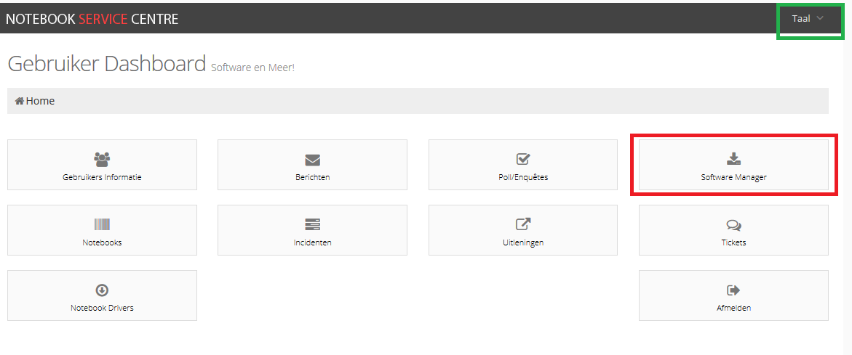
Click the box indicated by the RED square to access to available software, the GREEN square indicates where you can change the language.

SNT ICT help service:
If you have any trouble with the ICT facilities on the university you can call the helpdesk at Student Net Twente or check their site for helpful manuals regarding the configuration of WIFI, VPN or other ICT related services. Their site can be found here:
http://www.snt.utwente.nl/helpdesk/handleidingen

Campusnet:
Many students that live on the campus have their own dataserver. Most of them are kind enough to share their backups of games, movies and applications. The following website allows you to search for them:
http://search.student.utwente.nl/search

