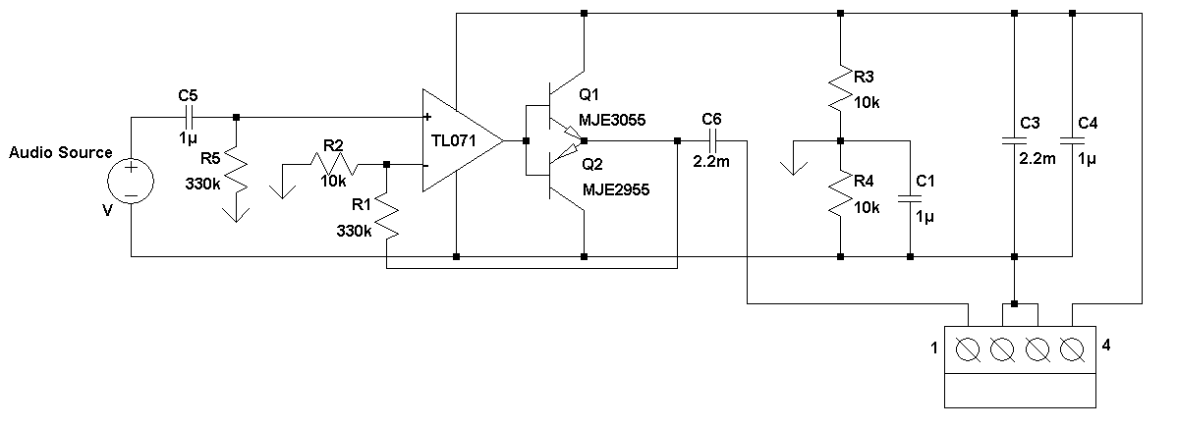

Terminal | Function
1 | Positive end speaker (Red)
2 | Negative end speaker (Black)
3 | Negative voltage supply
4 | Positive voltage supply

